CS343 Project 2 – Database Report

1. Database Design Overview
The application uses SQLite through Prisma ORM. The database stores users and sessions, hackathon groups, teams and invitations, programming problems and test cases, team files, and graded submissions. The design uses foreign keys and junction tables to represent one-to-many and many-to-many relationships while avoiding duplicated data.

2. Entity-Relationship Diagram
The ER diagram below reflects the current Prisma schema used by the project.
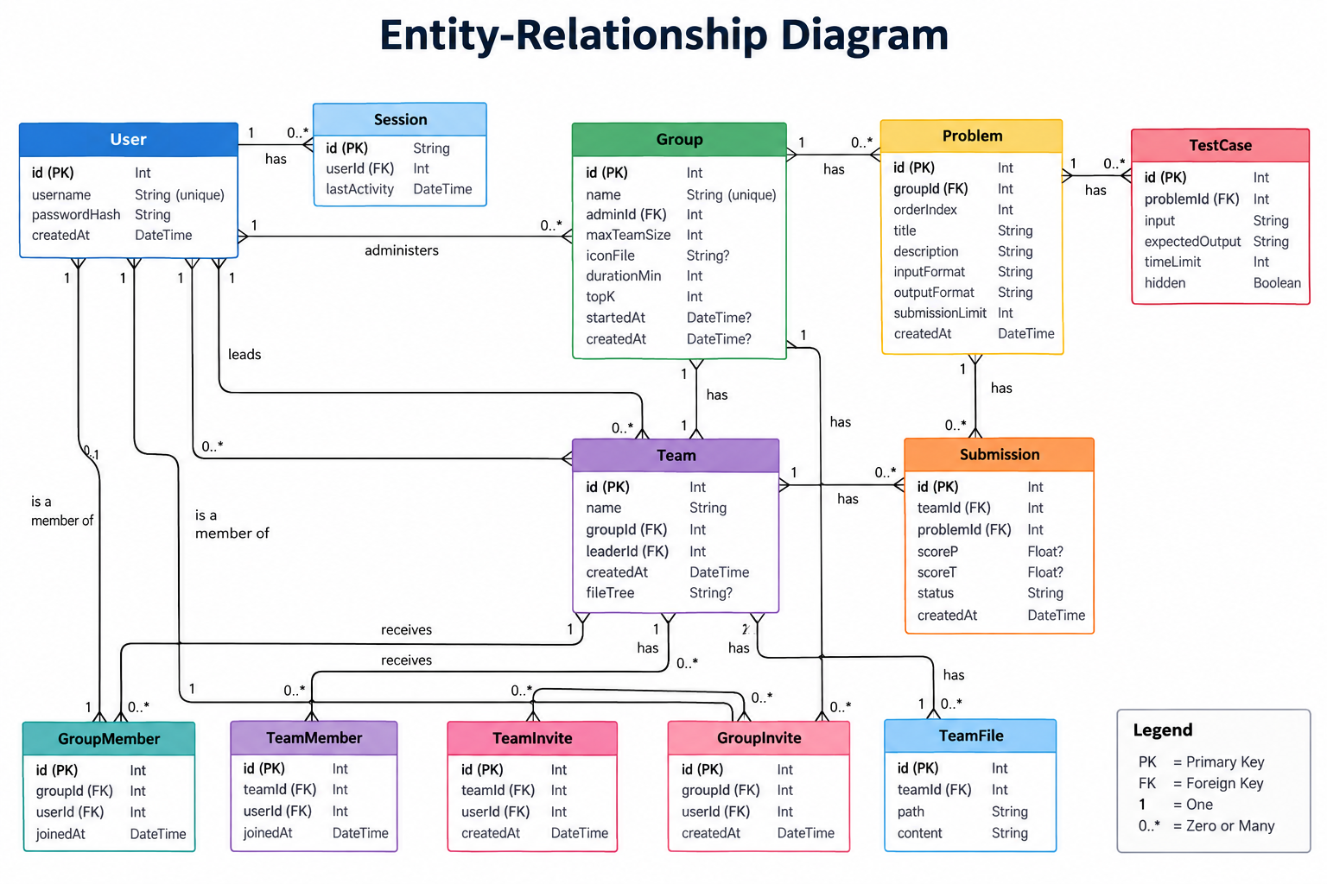
Figure 1: Entity-Relationship Diagram

3. Main Relationships
- A User can have many Sessions, administer Groups, lead Teams, and belong to Groups and Teams through GroupMember and TeamMember.
- A Group contains many Teams, Problems, GroupMembers and GroupInvites.
- A Team belongs to one Group, has one leader, and can have many TeamMembers, TeamInvites, TeamFiles and Submissions.
- A Problem belongs to one Group and has many TestCases and Submissions.
- A Submission belongs to exactly one Team and one Problem and stores the calculated leaderboard values scoreP and scoreT.

4. Normalization
All relations are designed to satisfy Third Normal Form (3NF). Each table has a primary key, attributes contain atomic values, non-key attributes depend on the whole key, and there are no unnecessary transitive dependencies between non-key attributes. The table below summarises this.
Relation | Normal Form | Reason
User | 3NF | id is the primary key; username is unique; all other attributes describe only that user.
Session | 3NF | Each session is identified by id and stores only its user reference and last activity time.
Group | 3NF | All settings depend directly on the group id; adminId is a foreign key to User.
GroupMember | 3NF | Junction relation between User and Group; the unique (groupId, userId) pair prevents duplicate membership.
Team | 3NF | Team attributes depend on the team id; groupId and leaderId reference Group and User.
TeamMember | 3NF | Junction relation between User and Team; no non-key attribute depends on another non-key attribute.
TeamInvite | 3NF | Stores one pending User–Team invitation; (teamId, userId) is unique.
GroupInvite | 3NF | Stores one pending User–Group invitation; (groupId, userId) is unique.
TeamFile | 3NF | Each file belongs to one team; path and content depend on the file record, with (teamId, path) unique.
Problem | 3NF | Problem details depend on id; groupId links the problem to its group and orderIndex defines its order within that group.
TestCase | 3NF | Each test case belongs to one problem and its input, expected output, time limit and hidden flag depend on that test case.
Submission | 3NF | Each submission links one team to one problem; scoreP, scoreT, status and createdAt describe that submission only.

5. Conclusion
The database design separates users, memberships, invitations, teams, problems, test cases, files and submissions into focused relations. Foreign keys preserve referential integrity, while unique constraints prevent duplicate memberships, invitations, team names within a group, problem order positions, and team file paths. This keeps the schema simple, consistent and suitable for the features required by the hackathon platform.

